Configure First Robotics

Java Developer

Workstation

In a bunch of not that difficult steps unless you’re in a real hurry and don’t have admin rights on the computer.

These instructions are intended for the 2016 version. It will be modified for 2017. Count on it.

Check PROGRAMS under the control panel to see if the Java SDK is already installed.

If NOT: download the Java Software Developers Kit (SDK) from the vendor.

http://www.oracle.com/technetwork/java/javase/downloads

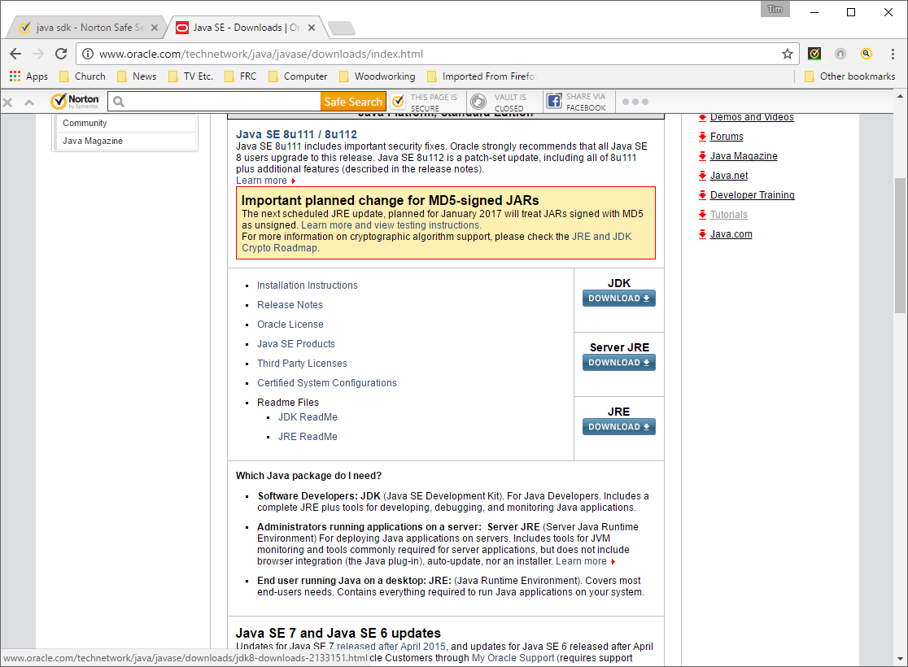

NEVER use a 3rd party source for downloads like this. You will probably receive bonus add-ons that you really DO NOT WANT.

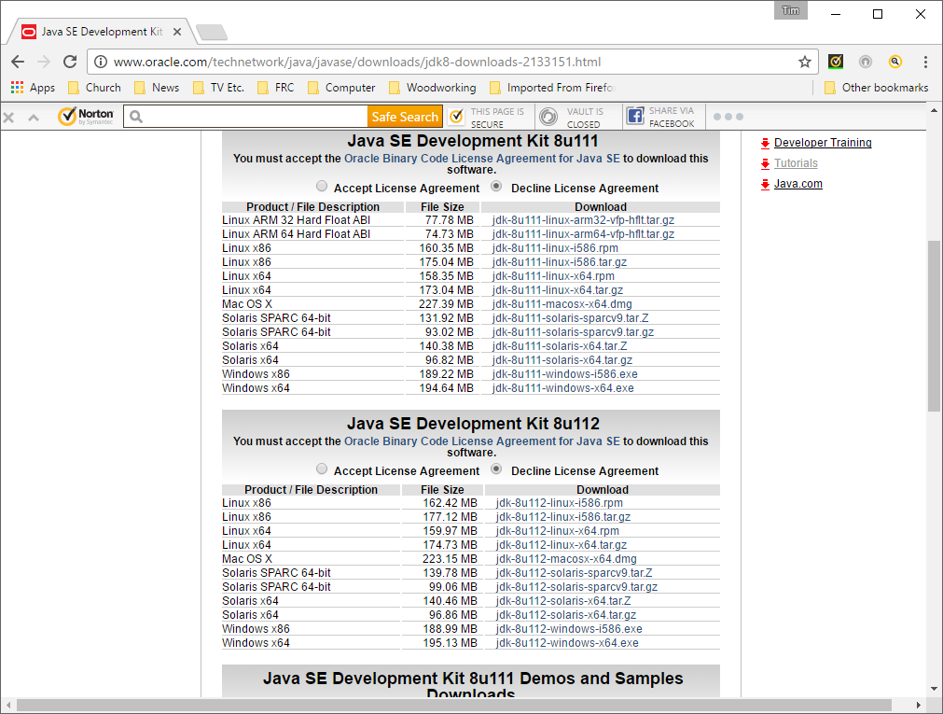

Check your workstation for the platform and version to install.

Windows needs to know if it’s 32 bit (x86) or 64 bit (x64).

Check the Accept radio button.

Perform the download and install the latest stable SDK for your platform. For school machines, this will require a faculty member to enter credentials

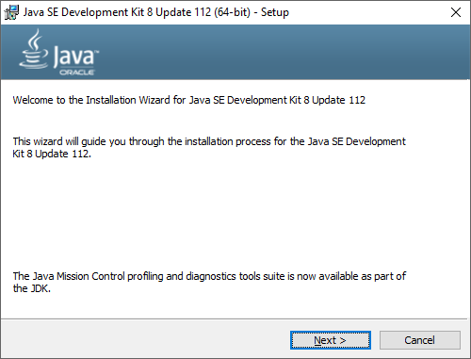Walk through the guided installation steps.

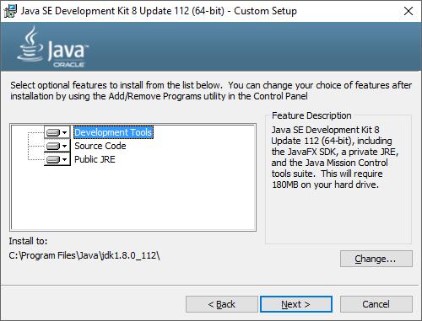

Keep all the options just in case.

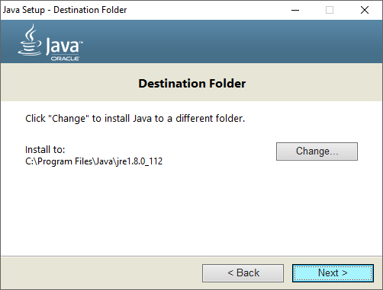Use the default installation path, it makes it easier to find things later on.

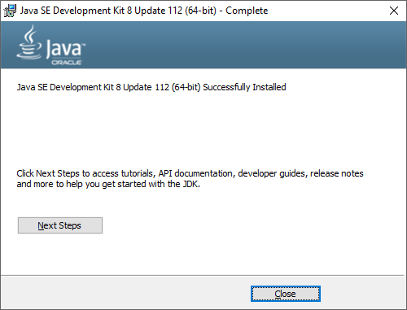

Done…

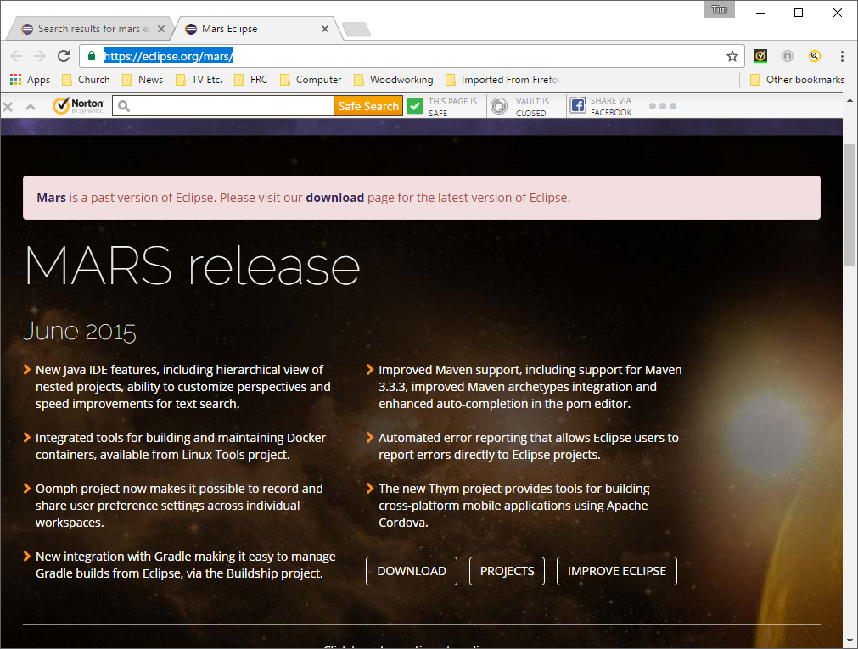

Go to eclipse.org and search for the Mars version of the tool.

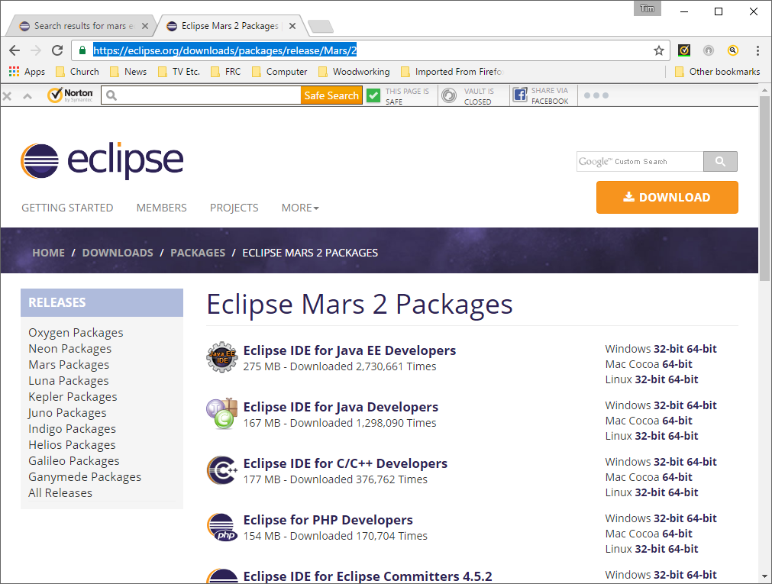

Pick the Mars Eclipse IDE for Java Developers (not the EE version) for your workstation.

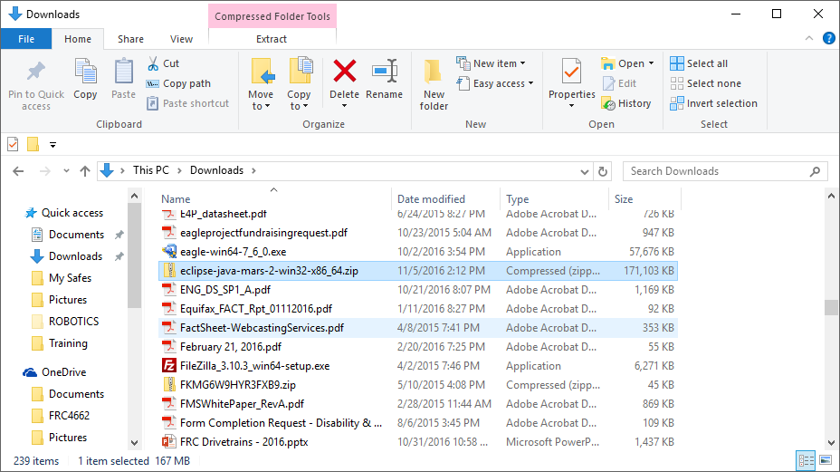Eclipse downloads as a zipped file in the standard download path.

Unzip it and designate your user path on a school machine (so it travels with you) or the C drive root if you’re installing on a personal PC or Mac.

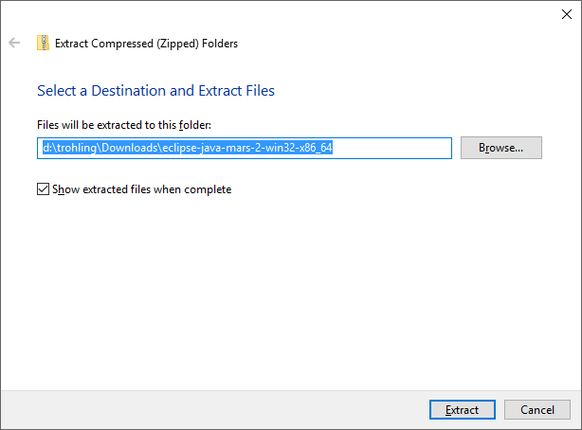

Extract target. This is not a good folder. Remember that the unzipped path will inlcude “eclipse” at the high level, so “C:\” will end up with “C:\eclipse”.

For school use, you can put it in your personal folder group. It will travel with you. But you have to be on a machine with a Java JDK that matches the configuration just installed.

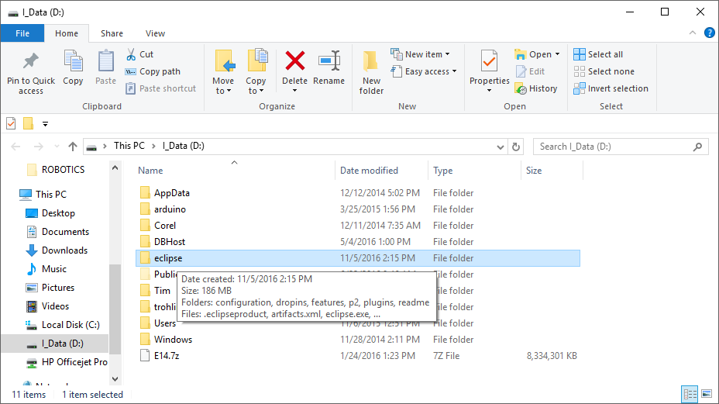And it ends up here:

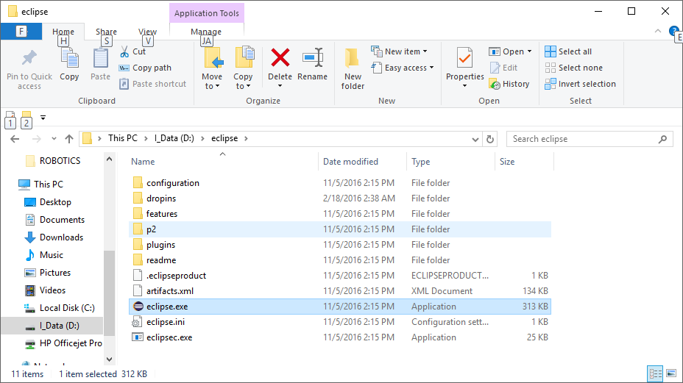Eclipse does not show up in the Control Panel Programs list. All you have to do is click on the “eclipse” application. Usually it’s easier to create a shortcut on the desktop, or pin it to the taskbar, or both.

Start eclipse and go into the following steps to configure it for FRC java development.

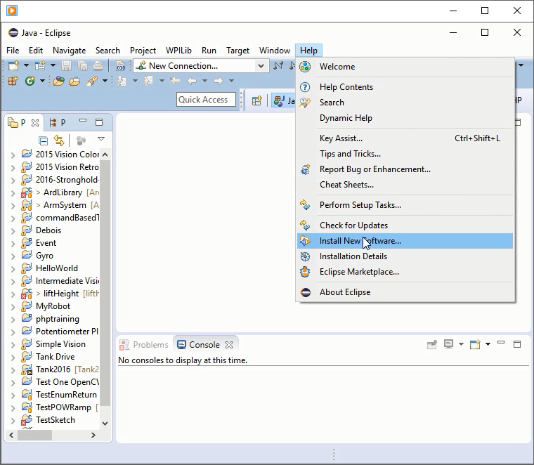

From the eclipse menu drop-down pick help>install new software.

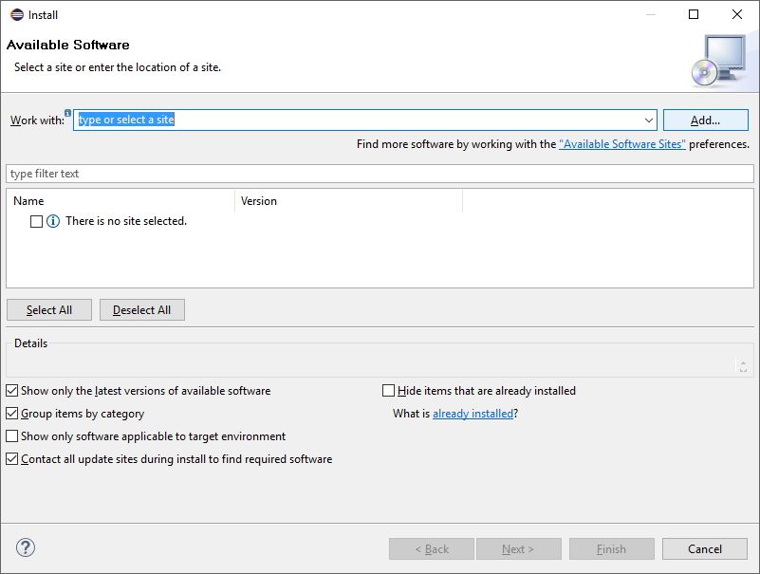Use the <Add…> button to pick up added features.

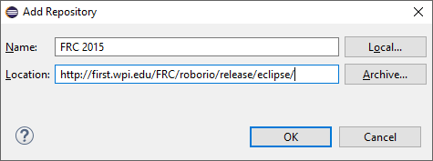

Add the First WPILIB plug-in for Java

The Name is arbitrary, but reference FRC for later searches. Location is the URI shown.

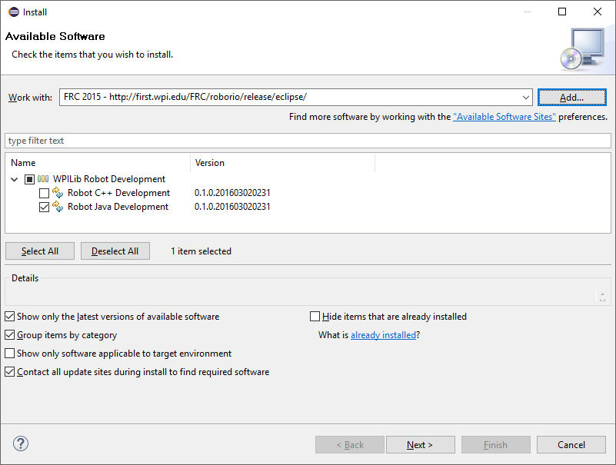Click <OK> and eclipse will search for the WPLIB entries available for download. Only the Java set is needed.

<Next> will trigger a download and install process.

Eclipse will restart to enable the plug-in for use.

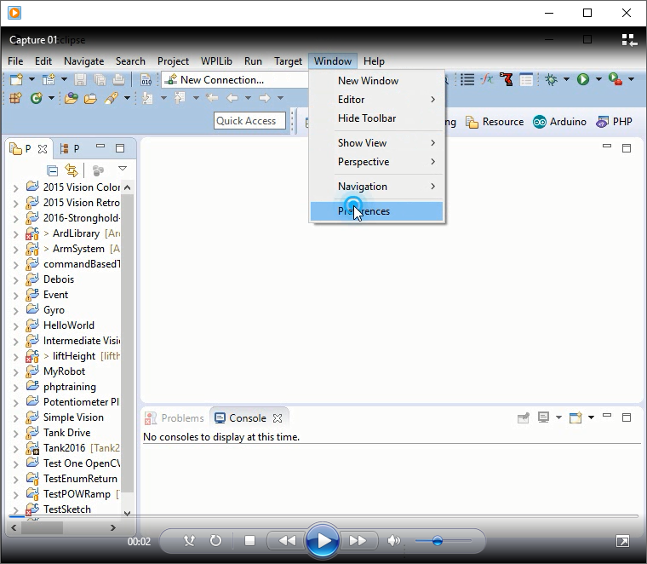

From #the eclipse menu drop-down:

Windows>

Preferences>

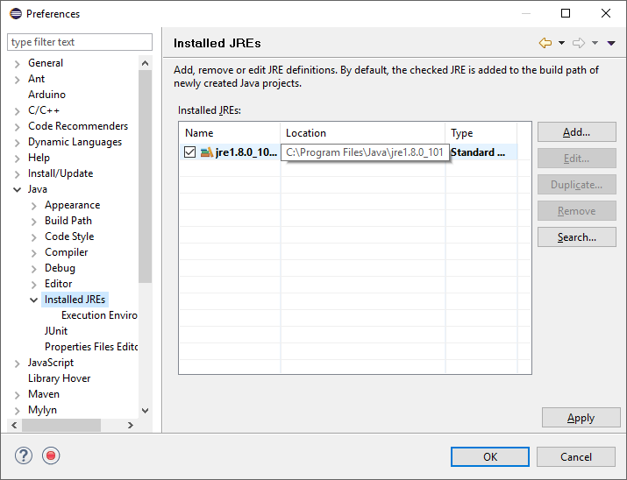

Under Java make sure the JDK is the installed JRE.

If NOT, then highlight the line and <edit>

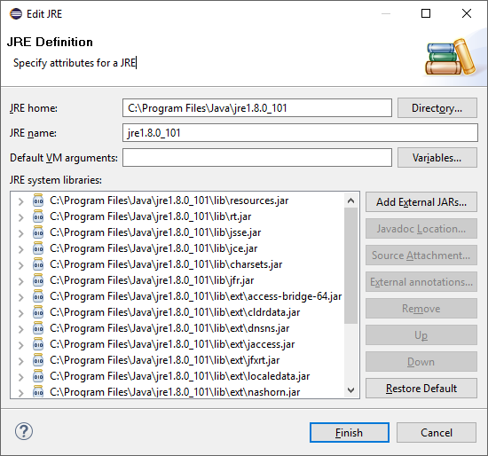This one points to a JRE. Click <Directory>

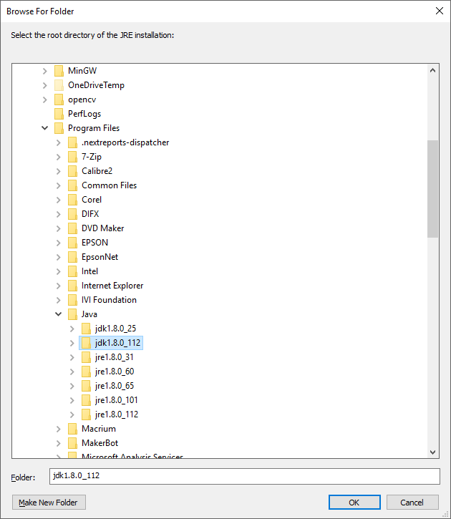Find the installed Java versions under C:/Program Files/Java/ and pick the JDK downloaded earlier.

Highlight the JDK and click on <OK>

You’ll go back to the previous panel, which will take a few seconds to refresh the list to the just selected JDK entries.

This machine has a few old versions that haven’t been cleaned up…

If you hit <OK> and exit Preferences, just select the drop-down again to continue with the configuration.

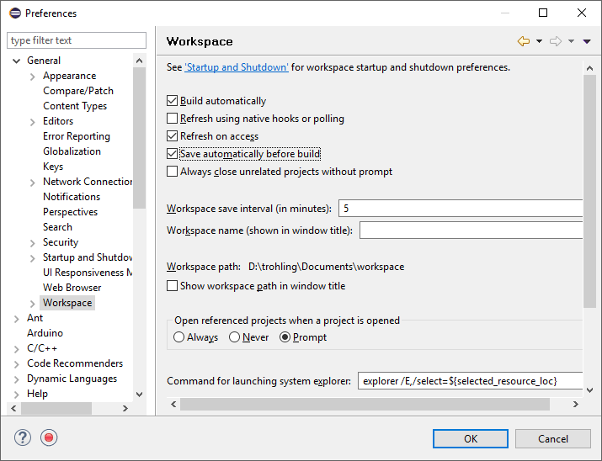Back to General and select Workspace.

Check

Build Automatically

Refresh on accesss

Save Automatically

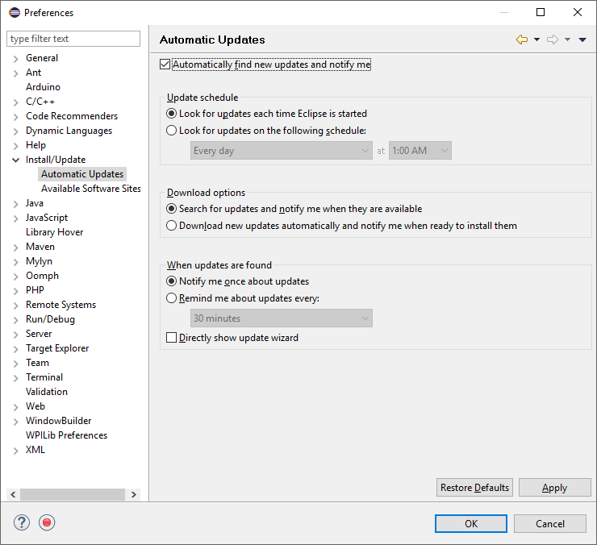

Install/Update

Automatic Updates

Check

Look for Updates each time

Search and notify

Etc. as shown

<OK> saves the changes and exists Windows>Preferences.

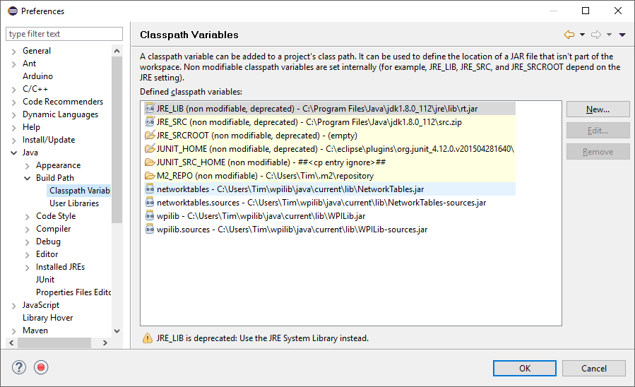Back to Windows>Preferences and check under Java>Build Path> Classpath variables for the four entries shown here at the botton. If they’re missing, use the <New…> button.

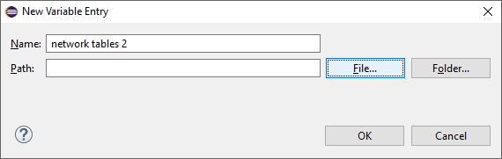The name is arbitrary, but again use something that’s easy to reference later.

Pick the <File…> button

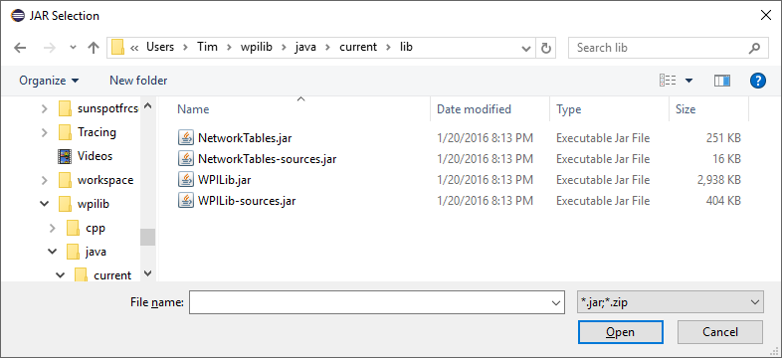The WPILIB plug-in will insall under your personal folder. Look under c:/user/yourid/wpilib/current/lib for these four files. Each one will need to be added to the Classpath Variable list.

<DONE> for now